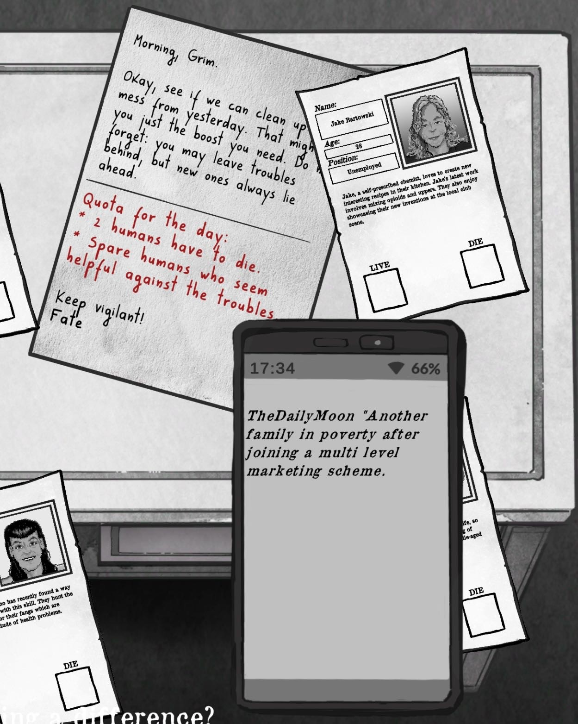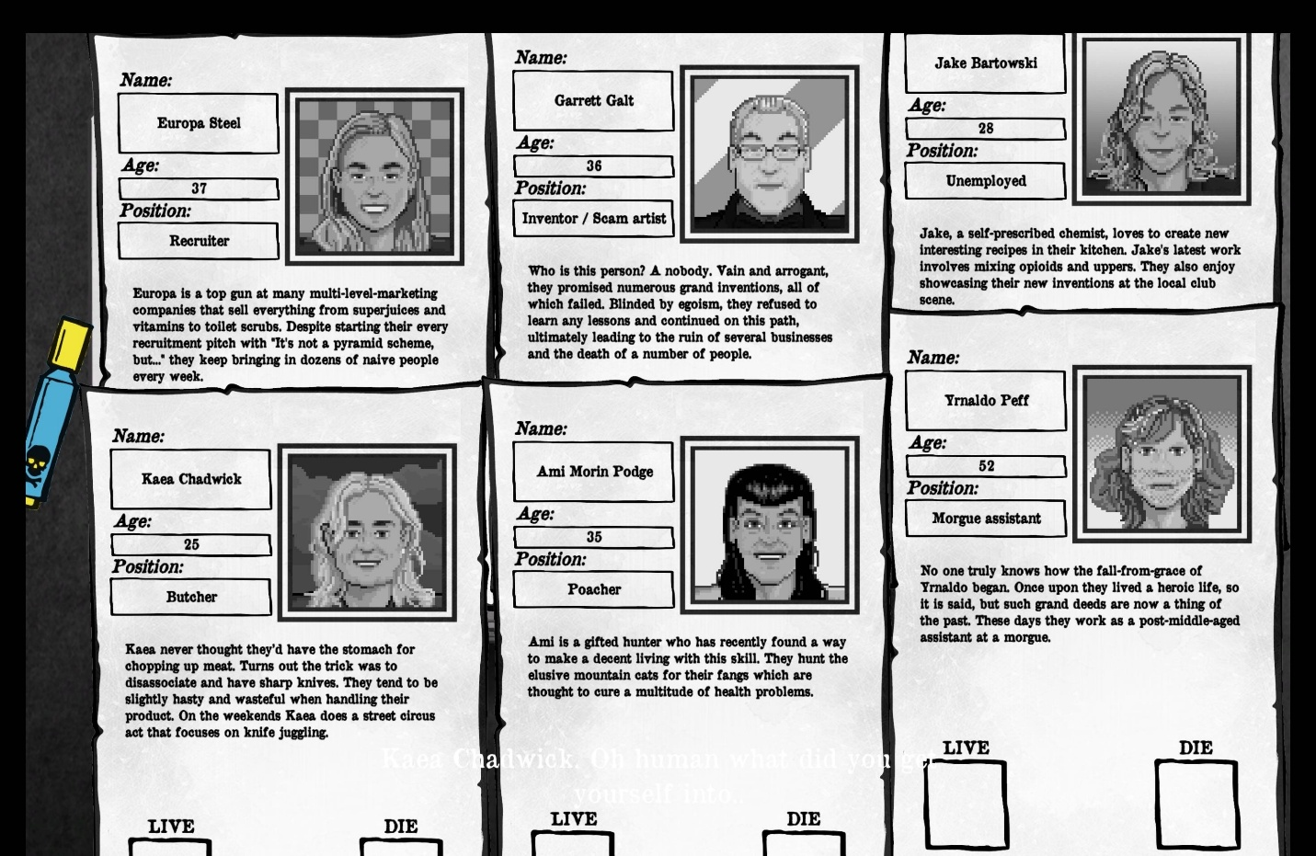
Instructions: Two people need to die. Spare humans who seem helpful against the trouble.
Who were marked as die: Europa Steel and Garrett Galt
Reasons: There is a news about family in poverty after join a multi level maketing scheme, so i chose Europa. Although she is doing well on her job, it would make some naive people become poor. What she doing seems to contribute to the problem.
I found it interesting that some people’s job are very unusual shuch as poacher and morgue assistant. Then, I had difficulty deciding who to die between Garrett and Ami Morin Podge. Aim’s job is a hunter who hunt the elusive animals, which is harmful to the environment. However, the profile also mentions that the fangs can cure many health problems. Therefore, I chose Garrett to die because he is a bad inventor and scam artist. What him doing is leading to the ruin of several businesses and the death of a number of people. He doesn’t seem helpful against the trouble either, so I chose him to die.

